## Installing and setting up Mongoose:

## 

## 

## 

## Create a person with this prototype:

## 

## 

## Create and Save a Record of a Model:

## 

## Create Many Records with model.create()

## 

## Use model.find() to Search Your Database

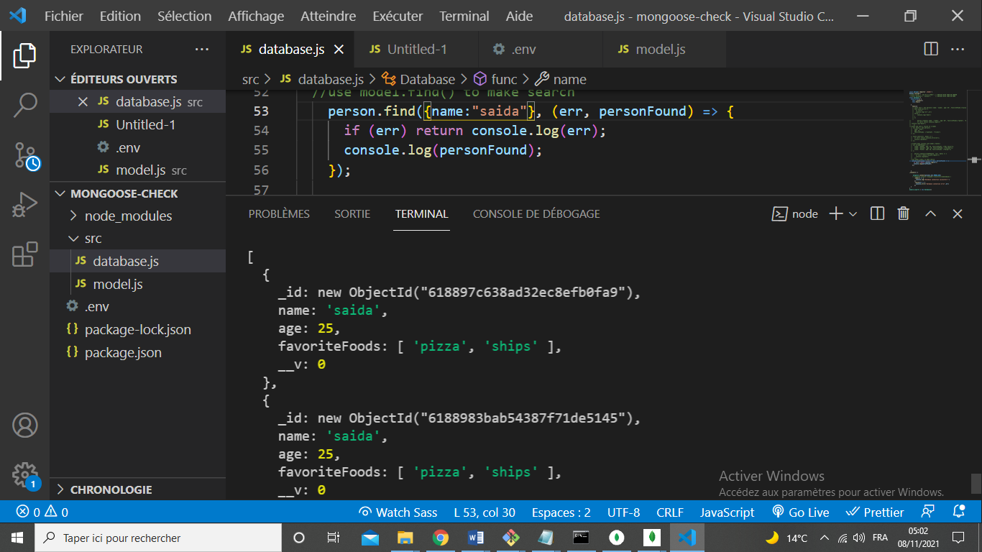

## Use model.findOne() to Return a Single Matching Document from Your Database

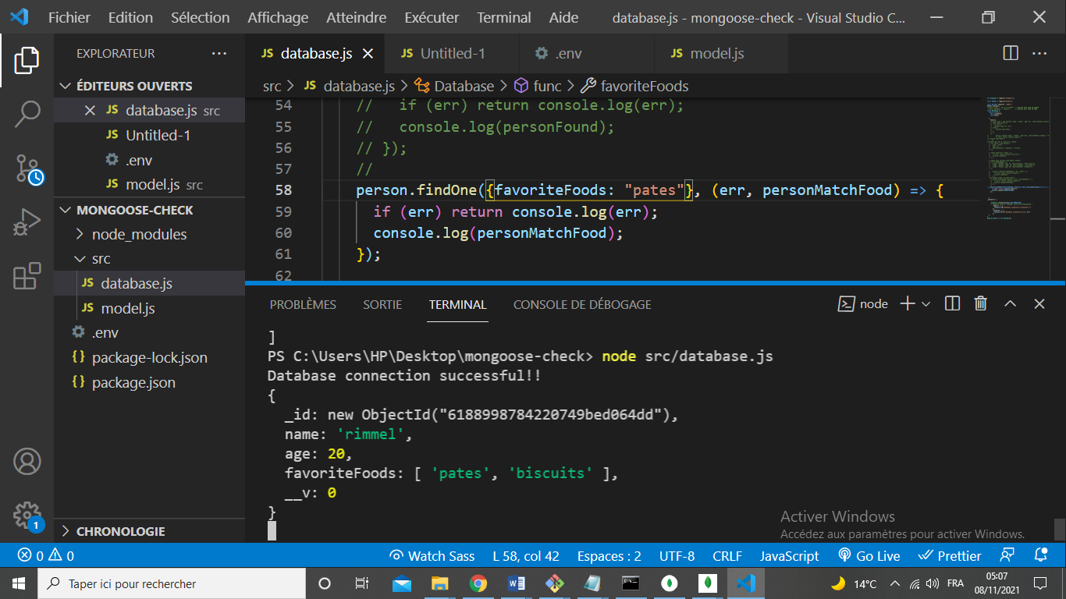

## Use model.findById() to Search Your Database By _id

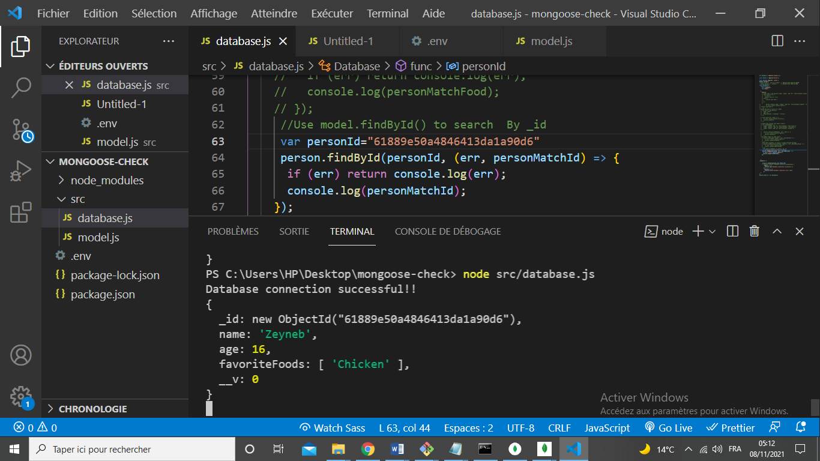

Perform Classic Updates by Running Find, Edit, then Save

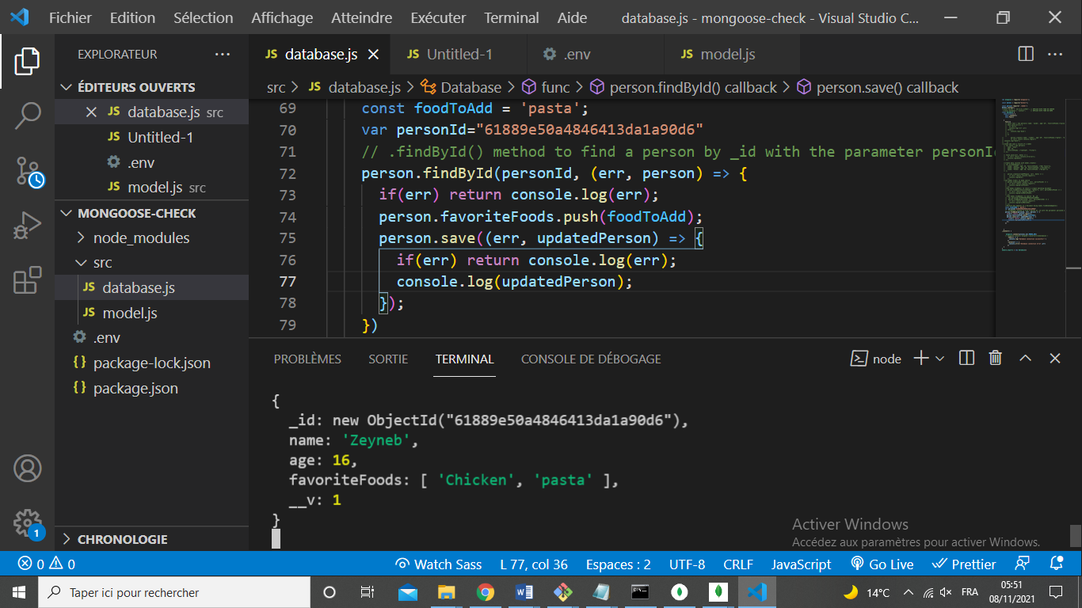

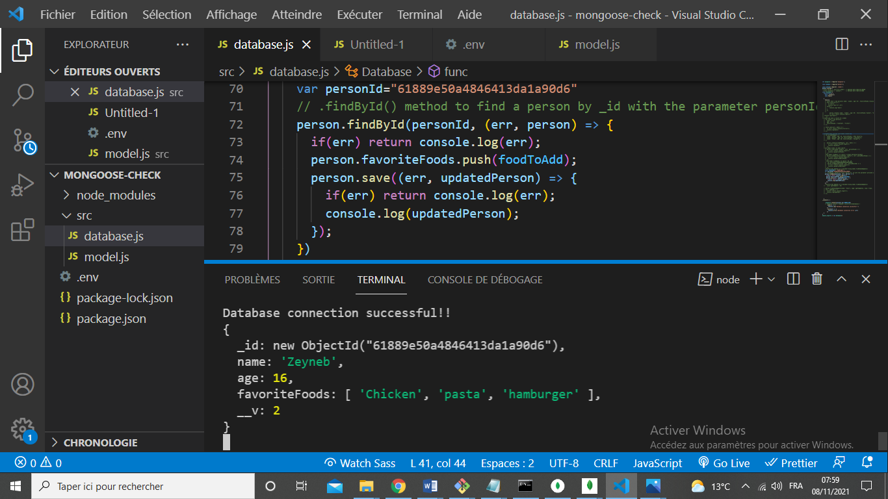

## Perform New Updates on a Document Using model.findOneAndUpdate()

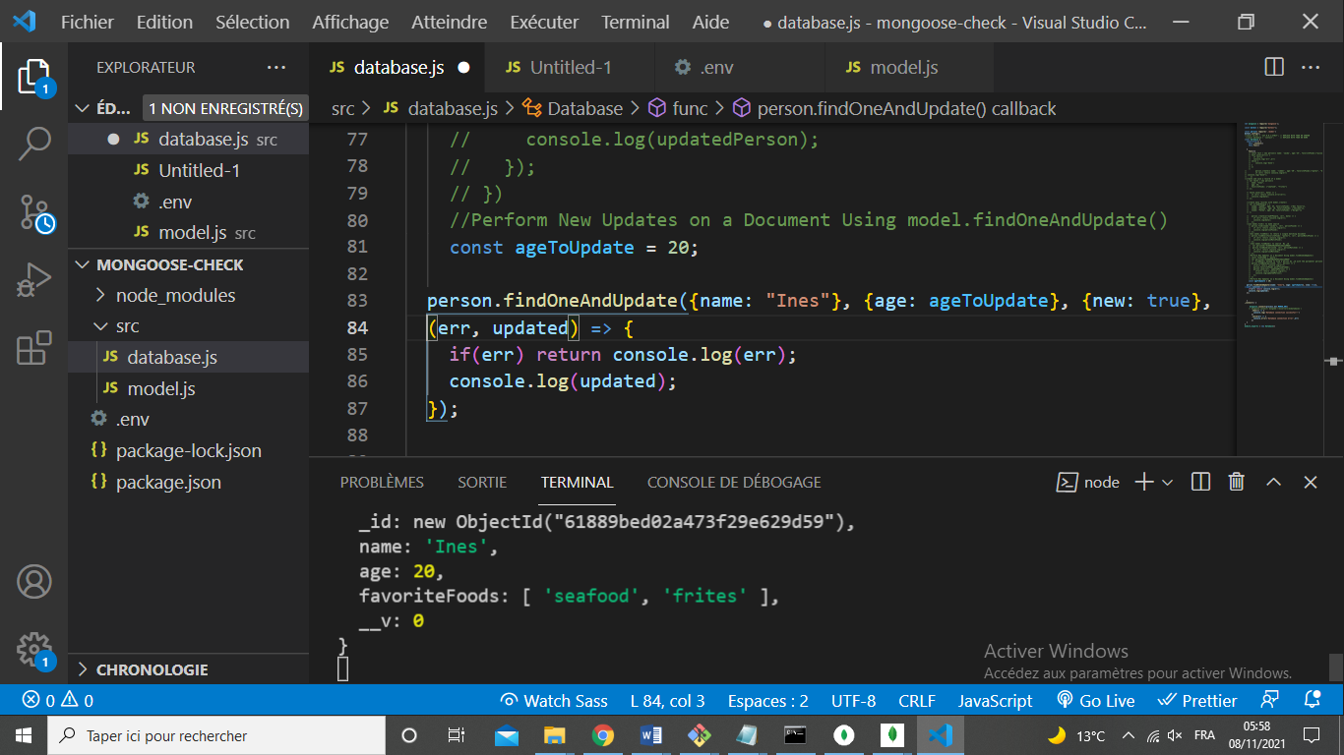

## Delete One Document Using model.findByIdAndRemove

## 

## 

## 

## 

## 

## MongoDB and Mongoose - Delete Many Documents with model.remove()

## 

## 

## Chain Search Query Helpers to Narrow Search Results

